

# SESHADRI RAO GUDLAVALLERU ENGINEERING COLLEGE

**PHYSICAL ACTIVITY FITNESS PREDICTION USING IBM WATSON**

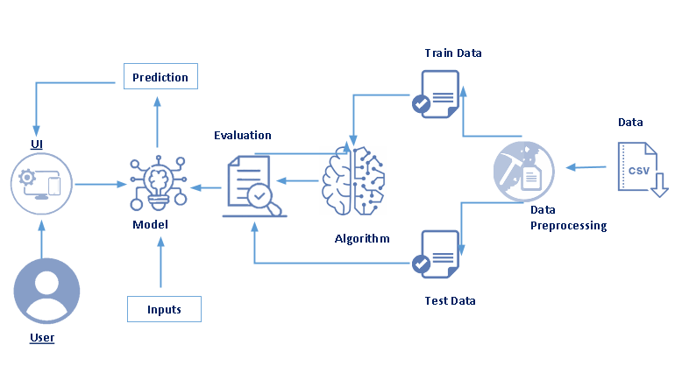

**SUBMITTED BY:**

**KATRAGADDA JAYA KINNERA**

**PIN: 20485A0319**

**Content**

1. **INTRODUCTION**
   1. Abstract

The use of this project. What can be achieved using this.

* 1. Overview

A brief description about your project

1. **LITERATURE SURVEY**
   1. Existing problem

Existing approaches or method to solve this problem

* 1. Proposed solution

What is the method or solution suggested by you?

1. **THEORITICAL ANALYSIS**
   1. Block diagram

Diagrammatic overview of the project.

* 1. Hardware / Software requirements

Hardware and software requirements of the project

1. **EXPERIMENTAL INVESTIGATIONS**

Analysis or the investigation made while working on the solution

1. **FLOWCHART**

Diagram showing the control ﬂow of the solution

1. **RESULT**

Final ﬁndings (Output) of the project along with screenshots.

1. **ADVANTAGES & DISADVANTAGES**

List of advantages and disadvantages of the proposed solution

1. **CONCLUSION**

Conclusion summarizing the entire work and ﬁndings.

1. **FUTURE SCOPE**

Enhancements that can be made in the future.

1. **BIBILOGRAPHY**

References of previous works or websites visited analysis about the project.

**1. INTRODUCTION**

### Abstract :

All-round development strategy of quality education makes primary and secondary school students not only pursue the improvement of achievement but also carry out physical exercise. Physical training is the material basis for students to study other disciplines, and the core is to improve students’ own physical quality and increase their physique. Having a strong body helps students have certain physical strength to study in other courses. In recent years, in the background of the scientific era, college students in China obviously have some problems, such as insufficient awareness of physical exercise and serious decline in physical fitness. Nowadays, teenagers are addicted to games

and go out to become members of the low-headed people. Nowadays, it is very unhealthy for teenagers to go out with their mobile phones as “low-headed people.” In order to avoid college students getting rid of this living condition, colleges and universities carry out physical fitness tests every year to promote contemporary college students to strengthen exercise. College students, as the main force in the future construction of the motherland, should not only master professional knowledge but also improve their physical fitness. Good health is the greatest capital in one’s life.

Every year, some students fail to pass the physical fitness test in universities. It stands to reason that college students are in the age of high youth, and physical fitness test should be a piece of cake for them. In the face of the inconsistency between the predicted results and the actual results, this paper analyzes this. Based on the above situation, With the aim of improving students’ training efficiency

and physical performance, the physical performance prediction model of deep learning is designed and analyzed to predict the performance, analyze the influencing factors of the model and how to reduce the influencing components of the factors, and analyze and compare the performance of various prediction models to find out the best model, so as to make the predicted value closer to the true value.

### OVERVIEW:

Physical fitness is the material basis of energy output based on the three functional systems of human body, and physical fitness is improved through repeated movements of skeletal muscles.

Physical training is an important part of sports training, which is divided into general physical training and special physical training. General physical training is the basis of special physical training.

Physical training refers to improving the basic quality, extension ability, and sports level of the body to make it a skill of the trainees. The core task is to strengthen one’s own physique, improve the technical level of physical training projects, and obtain high scores. The fundamental purpose is to promote

college students to take physical exercise, improve their life types, and make them develop good

exercise habits. Its core significance lies in participating in training to improve their physical fitness

and improve the performance level of physical fitness test, so as to achieve the three views of shaping

their own posture, cultivating good temperament, and establishing positive and healthy in this process. This paper takes college students as the main body, including archery, yoga, running, rope skipping, and other sports training

## LITERATURE SURVEY:

### Existing problem

Now a days people faces lot of problems like cholestrol...heavy weights , obisety , heart stroke...etc due to lack of exersice, and does not know how to bulid a healthy body ...

They faces a problems like

1. Inadequate fitness club / center and high cost of fitness centre
2. lack of time
3. high costs at gyms

### Proposed solution

Due to above problems this app provides the how to be ﬁt , how much you are active.. it shows the step count...how much of calaries you burned today..how many hours you sleep.. is your body has to be ﬁt according to your weight..etc

All above are in free of cost by using a app..it can reduce the gym fee etc...and it shows how much healthy you are...

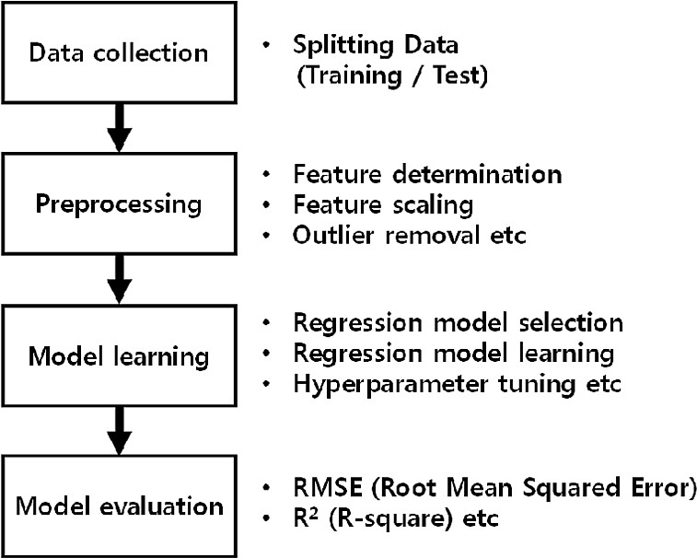

## THEORITICAL ANALYSIS

* 1. **BLOCK DIAGRAM:**

### Hardware / Software Requirements

Recommended System Requirements

* Processors:Intel® CoreTM i5 processor 4300M at 2.60 GHz or2.59 GHz (1socket, 2 cores, 2 threads per core), 8 GB ofDRAMIntel® Xeon® processor E5- 2698 v3 at 2.30 GHz (2sockets, 16 cores each, 1 thread per core), 64 GB of DRAMIntel® Xeon PhiTM processor 7210 at 1.30 GHz (1 socket,64 cores, 4 threads per core), 32 GB of DRAM, 16 GB ofMCDRAM (ﬂat mode enabled)
* Disk space: 2 to 3 GB
* Operating systems: Windows® 10, macOS*, and Linux*Minimum System Requirements
* Processors: Intel Atom® processor or Intel® CoreTM i3 processor
* Disk space: 1 GB
* Operating systems: Windows* 7 or later, macOS, and Linux
* Python* versions: 3.9

## Software requirements:

### anaconda navigator:

Anaconda is an open-source distribution for python and R. It isused for data science, machine learning, deep learning, etc. With theavailability of more than 300 libraries for data science, it becomesfairly optimal for any programmer to work on anaconda for data

science.

### Pycharm:

PyCharm is a dedicated Python Integrated DevelopmentEnvironment (IDE) providing a wide range of essential tools forPython developers, tightly integrated to create a convenientenvironment for productive Python, web, and data science development.

## EXPERIMENTAL INVESTIGATIONS

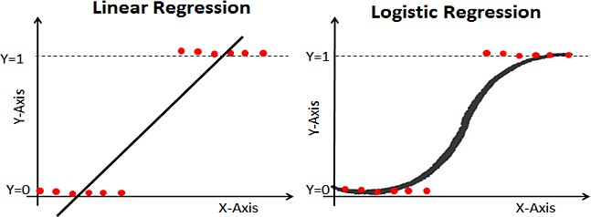

**Logistic Regression:**

This type of statistical model (also known as logit model) is often used for classiﬁcation and predictive analytics. Logistic regression estimates the probability of an event occurring, such as voted or didn’t vote, based on a given dataset of independent variables. Since the outcome is a probability, the dependent variable is bounded between 0 and 1. In logistic regression, a logit transformation is applied on the odds—that is, the probability of success divided by the probability of failure.

### Linear Regression:

Linear regression models are used to identify the relationship

between a continuous dependent variable and one or more independent variables. When there is only one independent variable and one dependent variable, it is known as simple linear regression, but as the number of independent variables increases, it is referred to as multiple linear regression. For each type of linear regression, it seeks to plot a line of best ﬁt through a set of data points, which is typically calculated using the least squares method.

## FLOW CHART

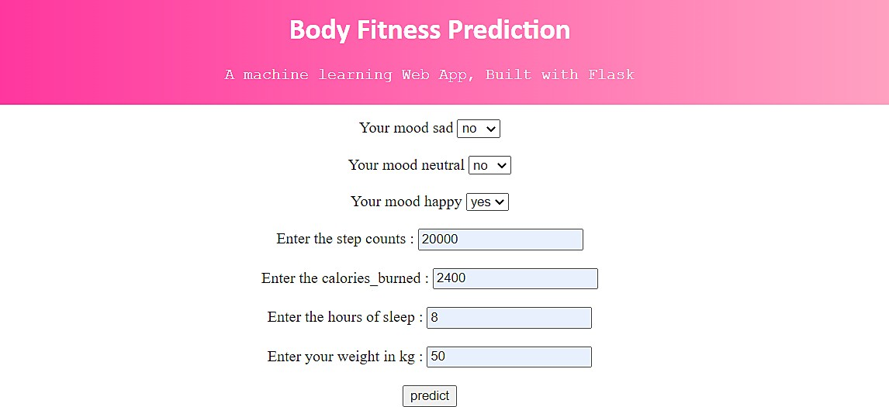

1. **RESULT**

If person is to be active or in active or inactive we can check by using this

app

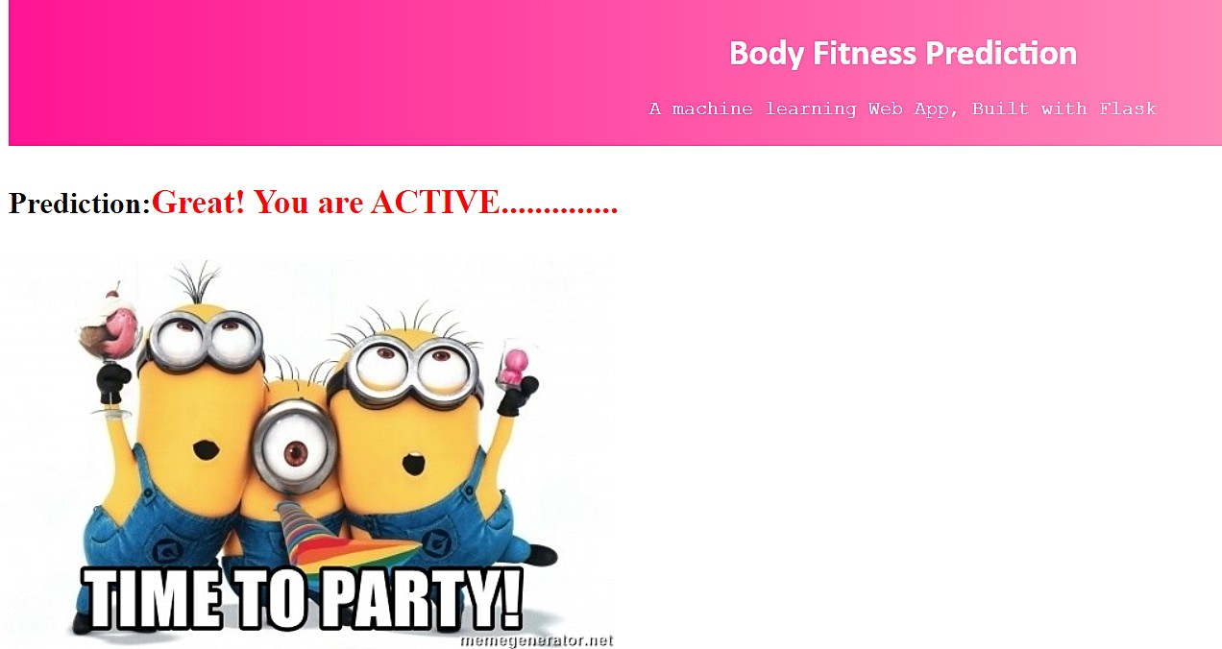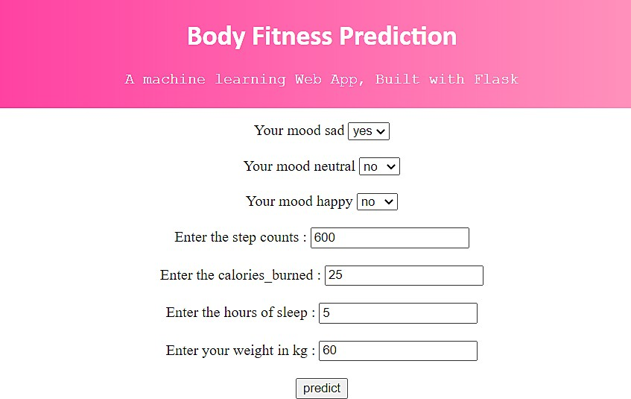

if you are sad the prediction of the app is,

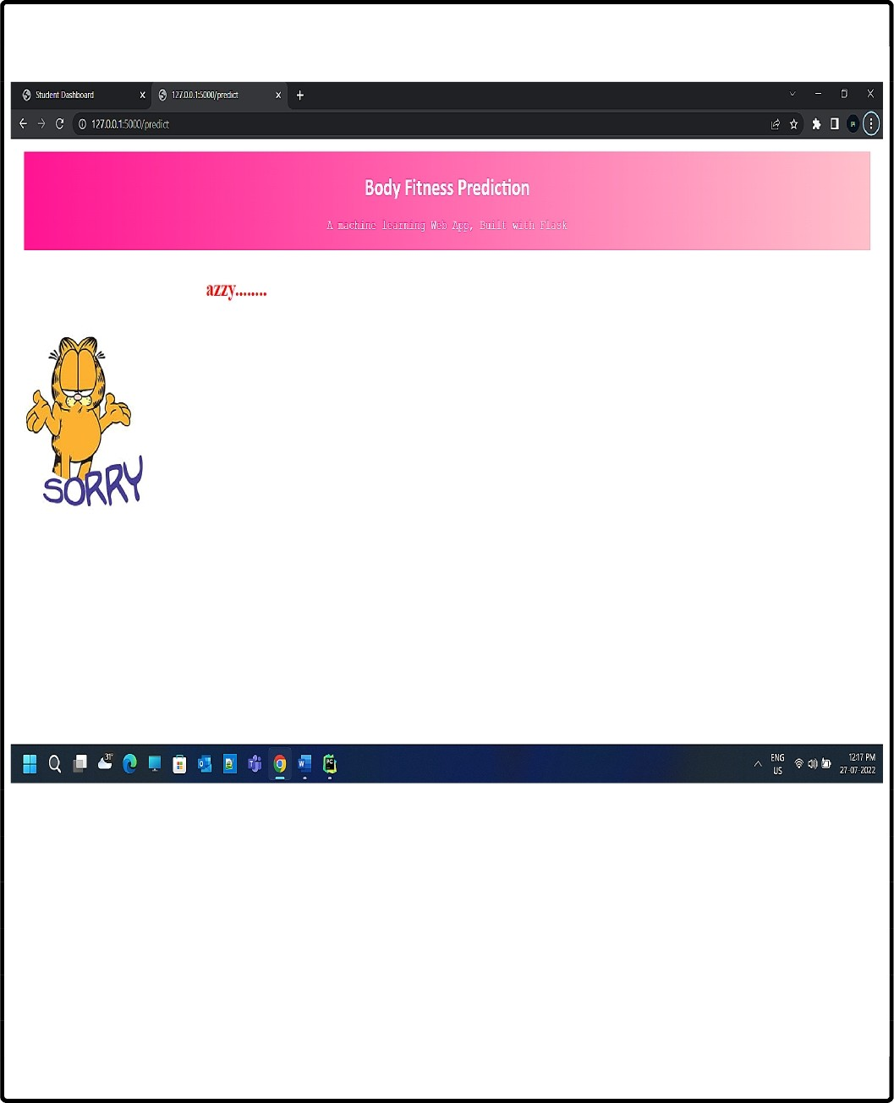

Prediction:Sorry! You are L

## ADVANTAGES & DISADVANTAGES OF A PROJECT

### ADVANTAGES:

1. Monitor Your Diet Easily. Weight watchers or people who want to gain weight can mention the type and amount of foods consumed at each meal. ...
2. Monitor Your Progress. ...
3. Give Free Health and Fitness Tips. ...
4. Track Your Foot Steps. ...
5. Provide Personal Health Coaches. ...
6. All In One Health Tool. ...
7. Keep You Motivated...
8. Fitness apps provide the nudge in the right direction 9.Get new ideas for your workout regime.

10.They create a healthy competition. 11.They create a healthy competition

**DISADVANTAGES:**

1. Counting calories doesn't make sense. .
2. Lack of automation. ..
3. Drained battery. ...
4. GPS problems. ...
5. Community support. ...
6. Too much data. ...
7. Gamification fails to provide long-term motivation. .
8. **conclusion**

Our paper adds to the scarcely researched area of training behaviour in fitness app users. There is still no consensus as to the exact definition of fitness app adherence, and there would seem not to be any previous research work that uses a deep learning approach to predict fitness app adherence over time. To the best of our knowledge, this is the first framework whose aim is to predict user adherence to training via a fitness app. The framework consists of two main stages: (i) characterization of users into user groups, based on their training behavior during the first three months; and (ii) the regression prediction for new users via an ensemble approach. Our results show that it is possible to take advantage of stored time-dependent data, in order to predict adherence over a given period of time. From the features studied, training frequency seems to be more relevant than time spent in training. For their part, our ensembles consisted of DL regressors and reflected good performance metrics. In the near future, we plan to incorporate demographic factors, as well as involvement variables in the workout regimen and user motivation, (intrinsic vs. extrinsic) into the DL architectural design. Additionally, we believe flexible longitudinal periods would be worth studying, the stages for which, we expect to be using a larger user database, which should enable thorough testing. The approach should focus on adhering to the principles of flexibility and resource efficiency, which will be essential in the creation of industrial 4.0 applications.

1. **future scope**

In today’s digital world we have a [mobile application](https://www.peerbits.com/mobile-application-development.html) for everything. The advent of smartphone has completely changed the way we live.

However, when it comes to health problems like obesity in children, and many other the mobile phones are often blamed.

But not every app on your phone is there to cause health issues. Recently, the trend of [health and fitness apps](https://peerbits.com/free-ui-psd-pfeet-fitenss-mobile-app.html) has gained strong momentum.

According to the research done by [Statista](https://www.statista.com/statistics/1154994/number-us-fitness-health-app-users/), In the year 2019, there were 68.7 million users in the US who used at least one health or fitness app. And in the year 2022, there will be 86.3 million users of health and fitness apps.

These apps are a useful tool for all the fitness freaks and to those who don’t go to gym and exercise often because of its easy functionality updates and assists them to exercise regularly.

1. **BIBILOGRAPHY**

**Installation of Anaconda Navigator:** [https://www.youtube.com/embed/5mDY](http://www.youtube.com/embed/5mDYijMfSzs)ijMfSzs **Installation Of Pycharm Professionals:** [https://www.youtube.com/embed/z73PyNDg](http://www.youtube.com/embed/z73PyNDgVyQ)VyQ **Installation Of Python Packages:** [https://www.youtube.com/embed/akj3_wTploU](http://www.youtube.com/embed/akj3_wTploU) **Data Collection:**

[https://www.kaggle.com/datasets/rishal005/admission-predict](http://www.kaggle.com/datasets/rishal005/admission-predict)

**Data Pre-processing:**

https://thesmartbridge.com/documents/spsaimldocs/Datapreprocessing

.pdf

**Handling Null Values:**

https://towardsdatascience.com/7-ways-to-handle-missing-values-in-

machine-learning-1a6326adf79e

**Data Visualization:** [https://www.youtube.com/embed/TLdXM0A7SR8](http://www.youtube.com/embed/TLdXM0A7SR8) **Splitting Dependent And Independent Columns:** [https://www.youtube.com/embed/A_V6daPQZIU](http://www.youtube.com/embed/A_V6daPQZIU) **Splitting The Data Into Train And Test:** [https://www.youtube.com/embed/xgDs0scjuuQ](http://www.youtube.com/embed/xgDs0scjuuQ)

**Training And Testing The Model:** [https://www.youtube.com/embed/yIYKR4sgzI8](http://www.youtube.com/embed/yIYKR4sgzI8) **Model Evaluation:**

https://towardsdatascience.com/the-5-classification-evaluation-metrics- you-must-know-aa97784ff226

**Flask Frame Work Refarance:** [https://www.youtube.com/embed/lj4I_CvBnt0](http://www.youtube.com/embed/lj4I_CvBnt0) **Flask Refarance To Run:**

[https://www.youtube.com/embed/UbC](http://www.youtube.com/embed/UbCWoMf80PY)WoMf80PY

**Train The Model On IBM:**

**Account Creation:** [https://www.youtube.com/embed/4y_zD-0Q3F8](http://www.youtube.com/embed/4y_zD-0Q3F8) **Train Model On IBM Watson:** [https://www.youtube.com/embed/](http://www.youtube.com/embed/TysuP3KgSzc)T[ysuP3KgSzc](http://www.youtube.com/embed/TysuP3KgSzc) **Integrate Flask With Scoring Endpoint:** [https://www.youtube.com/embed/ST1ZYLmYw2U](http://www.youtube.com/embed/ST1ZYLmYw2U)



: